|  |  |  |  |
| --- | --- | --- | --- |
|  | **Region (Deanery) Name** | Thames Valley & Wessex - NHS England South East | |
|  | **Title of post**  **Type of Training & duration of post** | * DCT Level DCT1/2 * 1 year | |
|  | **Training unit/locations** | *University Hospital Southampton (Southampton General Hospital)  *Royal Hampshire County Hospital, Winchester  *Independent sector treatment centre (Care UK), Royal South Hants Hospital, Southampton | |
|  | **Rotational Post information**  **and Duration** | * University Hospital Southampton (No rotation) * 1 year | |
|  | **Full address of unit/s where training is based** | University Hospital Southampton NHS Trust  Southampton General Hospital  Tremona Road  Southampton  SO16 6YD  Royal Hampshire County Hospital  Romsey Road  Winchester  SO22 5DG  Royal South Hants Hospital  Brintons Terrace, Southampton  SO14 0YG | |
|  | **Travel Commitment** | * Trainees will have to travel to Royal Soth Hants hospitals and Royal Hampshire hospitals in Winchester in addition to UHS * Access to a car would be an advantage | |
|  | **Name of Educational Supervisor, if known** | Badrinarayanan Srinivasan,  Madan Ethunandan, Andrew Webb, Rabin Singh KC, Edel Alrasheed | |
|  | **Contact details for Educational Supervisor** | Badri.srinivasan@uhs.nhs.uk | |
|  | **Description of training post** | The placement involves duties at three sites (Southampton General Hospital, Independent Sector treatment centre at Royal South Hants Hospital, Southampton and Royal Hampshire County Hospital, Winchester. All inpatient activities are based at Southampton General Hospital. There is no night time on-call commitment, which is covered by the hospital at night team. On-call experience is gained during standard working hours and up to 20.30. Annual leave and study leave is allocated, flexibility is offered when possible.1 in 6 on-call weekends Sat and Sun 0730 – 20.30 at the end of on call week 1. One FY2 (surgical) is part of the team and participates in the on-call rota. Salisbury district hospital DCT’s join the weekend on call with the UHS trainees.   * NO OVERNIGHT ON-CALL   Summary of Duties:   1. Attending OMFS and Oral Surgery Consultation Clinics 2. Outpatient and inpatient management of maxillofacial elective and emergency patients 3. Performing minor oral surgery under GA/LA/Sedation 4. Attending and assisting in major cases in theatre 5. Opportunities for audit/ research/ presentations/ publications 6. Attendance to formal teaching sessions   Summary of training and educational objectives:   1. Develop skills in the performance of exodontia and minor oral surgery. 2. Develop a further understanding of the assessment and management of maxillofacial trauma. 3. Develop a further understanding of the assessment and management of patients presenting with facial deformity 4. Develop a further understanding of the assessment and management of patients presenting with head and neck pathology. 5. Develop skills in managing dental emergencies and dental trauma 6. Develop an understanding of the management of medically compromised patients requiring dental or OMFS treatment. 7. Completion of competencies within all domains of the GPT curriculum 8. Develop and understand ward management of patients with OMFS elective and emergency admissions 9. This job involves intense understanding and working in a tertiary referral centre. | |
|  | **Suitable for Temporary Registrant?** | **YES** | **NO** |
|  | **Primary Care element**  **Performer Number required?** | **YES** | **NO** |
|  | **Pattern of working including any on-call commitment** | Due to the number of DCT1/2 Trainees there are a number of different timetables (all compliant) The provisional timetables are attached.  See Appendix 1 | |
|  | **Educational programme**  **summary** | Access is available to an excellent university hospital library on-site.  Formal teaching on Tuesday and alternate Friday afternoons.  Attendance at regional DCT study days provided by the Thames Valley & Wessex Dental Team. | |
|  | **Employment Details** |  | |
|  | **Employer** | * University Hospitals Southampton | |
|  | **Contact email for applicant queries referring to post** | * [medicalHR@uhs.nhs.uk](mailto:medicalHR@uhs.nhs.uk)   Tel: 02381206651  Mr Badrinarayanan Srinivasan  Consultant Oral & Maxillofacial Surgeon  University Hospital Southampton NHS Foundation Trust  Southampton General Hospital  Tremona Road  Southampton  SO16 6YD  Email address: [saira.saleemi@uhs.nhs.uk](mailto:saira.saleemi@uhs.nhs.uk)  Tel: 02381206097 | |
|  | **Link to relevant webpages** | [www.uhs.nhs.uk](http://www.uhs.nhs.uk) | |

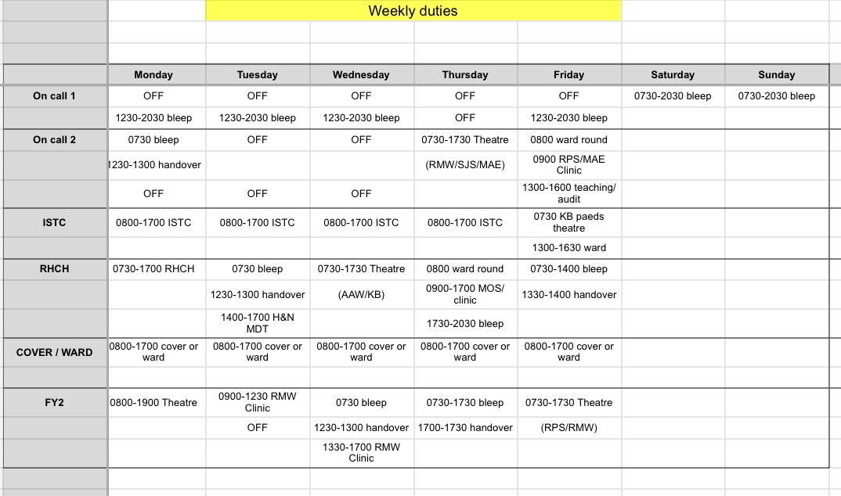

|  |  |  |
| --- | --- | --- |
| **WEEK 1** | **AM** | **PM** |
| MONDAY | Theatre | MOS LA |
| TUESDAY | IV / LA MOS | Clinic |
| WEDNESDAY | IV / LA MOS | Theatre |
| THURSDAY | Theatre | Theatre |
| FRIDAY | MOS LA | MOS LA |

|  |  |  |
| --- | --- | --- |
| **WEEK 2** | **AM** | **PM** |
| MONDAY | Clinic | MOS LA |
| TUESDAY | IV / LA MOS | MOS LA |
| WEDNESDAY | IV / LA MOS | Theatre |
| THURSDAY | Theatre | Theatre |
| FRIDAY | SGH | SGH |