GMC (General Medical Council) Self-Referral - Thames Valley Doctors in Training

Criminal / Regulatory Proceedings

Good Medical Practice (section 75) states that:
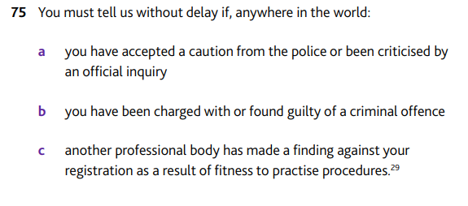
The GMC document Reporting criminal and regulatory proceedings provides full details of what you must tell the GMC about. This includes if you:
- Are found guilty of a criminal offence
- Are charged with a criminal offence
- Admit to an offence by accepting a caution or community resolution order
- Receive a cannabis warning
- Are given an injunction, a civil order or a Criminal Behaviour Order
- Have your registration restricted, or are found guilty of an offence, by another medical or other professional regulatory body

You do not have to tell the GMC about:
- Fixed penalty notices for disorder (with the exception of those issued at the upper tier penalty level)
- Payment of fixed penalty notice for a road traffic offence
- Payment of a fixed penalty notice issued by local authorities (e.g. for noise)
However, traffic offences which end up in court must be notified to the GMC.

Health concerns
Physical or mental ill-health may impact your ability to practise medicine.

If you have a new condition or a change to an existing condition which is not being effectively managed or a problem with alcohol or drugs you must inform the GMC.

You should also seek support from your GP or specialist.

The GMC offers specific guidance on managing health whilst practising as a doctor
https://www.gmc-uk.org/concerns/information-for-doctors-under-investigation/support-for-doctors

Other
In some circumstances, doctors who have been involved in incidents where their fitness to practise has been impaired may choose to make a self-referral.
This could include poor performance or other significant departures from Good Medical Practice.

How to self-refer
Self-referrals can be made online:
https://www.gmc-uk.org/concerns/raise-a-concern-about-a-doctor#refer-self

You can also call the GMC with any queries about self-referral, Monday to Friday 8 am–5.30 pm, and 9 am–5 pm on Saturday on 0161 923 6602.

In addition to notifying the GMC, you must inform your Responsible Officer and your employer/s.

For Doctors in Training within Thames Valley your RO (Responsible Officer) can be contacted via:
england.revalidation.tv@nhs.net or 01865 785 554

The RO will ensure you have access to the right support and can liaise with employers and educators on your behalf as needed.

Last, but not least, we recommend you seek advice from your medical defence organisation.

Not sure?
If you are uncertain as to whether something should be reported to the GMC, please contact the Revalidation Team for advice. If appropriate we are able to check with the GMC on an anonymised basis.
england.revalidation.tv@nhs.net or 01865 785 554

We treat all information received sensitively and will only disclose to others where this is absolutely necessary.

We recommend that you also discuss self-referral with your medical defence organisation.

Informing the RO or making a self-referral to the GMC for any of the above does not necessarily mean you cannot continue in training or employment. Prompt disclosure to the relevant people will ensure you can be given the right advice and support.

Scenarios

I have been charged with drink-driving, who do I need to tell?
You must inform the GMC, your Responsible Officer and your Employer.
You will need to keep the above parties updated with details of the outcome.
The GMC will open an investigation and will contact you alongside your RO and employing body. This is to establish whether there are any concerns about your fitness to practise which they should be considering alongside the charge/conviction.
In many cases, doctors who are convicted of drink-driving are issued with a warning from the GMC and do not have any restrictions placed on their practice.

I have been questioned by the police about an alleged assault, I haven’t been charged but the police have said they are still reviewing evidence
We strongly recommend that you contact your RO/Revalidation team initially for guidance. They can liaise with the GMC in confidence to ensure you are given the correct advice.

I have been interviewed by the police but wasn’t charged and the police have said that I am no longer under investigation, does the GMC have to know?
As above please contact your RO/Revalidation team for guidance.

I have received a fixed penalty notice for speeding, my colleague said I have to tell the GMC – are they right?
No – speeding and other traffic offences that are resolved by a fixed penalty notice do not have to be notified to the GMC. However, you should reflect on the incident and ensure you have taken steps to reduce the risk of re-occurrence.
Please note that when applying for specialty training you will need to declare this.

Does my ES (Educational Supervisor) need to know that I have accepted a caution?
Strictly speaking no, if you have informed the required parties (GMC, Responsible Officer and Employer) then this information does not have to be shared with them. However, as a key source of support your ES may be well placed to help you particularly if you feel your training is being affected.

Good Medical Practice - https://www.gmc-uk.org/-/media/documents/good-medical-practice---english-1215_pdf-51527435.pdf
Reporting criminal and regulatory proceedings - https://www.gmc-uk.org/-/media/documents/reporting-criminal-and-regulatory_pdf-58841314.pdf

