Registration, Licensing and Revalidation
With the introduction of Revalidation in 2012, the GMC (General Medical Council) changed the way registration and licensing of doctors works in the UK. It is now a legal requirement to hold a licence to practise as well as GMC registration in order to provide medical services in the UK.
Registered with a Licence to Practise
If you are working as a doctor in the UK, you will need to be Registered with a Licence to Practise. In order to maintain your license, you are required to:
- Collect supporting information about your practise
- Have an annual appraisal
- Revalidate your licence every five years through one of three routes (below)
Connection to a Designated Body | Connection to a Suitable Person | Annual Return and  Revalidation Assessment
GMC makes decision based on recommendation from Responsible Officer | GMC makes decision based on recommendation from Suitable Person | GMC makes decision based on information received directly from you

There is no option to be “Registered with a Licence to Practise” and not adhere to the above requirements. If you do not need a licence you should consider relinquishing it until you do. See the section on being “Registered without a Licence to Practise” below. Failure to confirm to the GMC your status and ensure the appropriate connection may result in your licence being removed.
Is anything different for doctors in training?
Revalidation for doctors in training is largely the same as for any other doctor, apart from three key points:
- They collect supporting information about their practice as a matter of course, because it is incorporated into their curriculum requirements
- They have Annual Reviews of Competence Progression (ARCP) instead of annual appraisals
- In addition to revalidating every five years, they have an extra revalidation around the time they complete their training (CCT (Certificate of Completion of Training)) to become a consultant or GP.
Doctors in training revalidate through the first route, Connection to a Designated Body (their Local Team or Deanery) and the GMC makes its decision based on a recommendation from the Responsible Officer (the Postgraduate Dean). Check/update your connection via your GMC Online Account.

Connecting to a Designated Body

You are: | Your Designated Body is:
In a training post provided by NHSE Education Thames Valley (Oxford Deanery) | NHSE (NHS England) Education Thames Valley.
A Military trainee | Defence Postgraduate Medical Deanery
In a LAS post (Locum Appointment for Service) | Your employing Trust
An F1 Foundation Doctor | You do not need to have a designated body as you do not yet have a full licence to practise

What about other junior doctors who are working but not in a training programme?
This group of doctors are like any other non-trainee doctor and should collect supporting information, have an appraisal every year and revalidate every five years through one of the three routes described. These doctors must have a connection to a designated body (usually their employing trust).
What about doctors who are “just doing the odd locum”?
This group of doctors should still collect supporting information, have an appraisal every year and revalidate every five years through one of the three routes described. Most of these doctors will need a connection to a designated body (e.g., NHS Professionals or another locum agency), others may need to make an Annual Return.

- THESE REQUIREMENTS APPLY EVEN WHEN DOCTORS ARE IN A SHORT-TERM TRUST POST – SPEAK TO YOUR EMPLOYING TRUST FOR ADVICE.

- IF YOU CANNOT IDENTIFY A DESIGNATED BODY OR YOU ARE NOT WORKING IN A MEDICAL CAPACITY SPEAK TO THE GMC TO ENSURE YOU MEET REVALIDATION REQUIREMENTS.

- IF YOU DO NOT UPDATE THE GMC, YOU RISK LOSING YOUR LICENCE TO PRACTISE.
Registered without a Licence to Practise
If you choose not to practise in the UK for a period, whilst working overseas or taking a career break for example, it is advisable to relinquish your licence to practise but keep your GMC registration. This means you will not have to participate in revalidation and will pay a reduced annual retention fee, but you also will not be able to carry out any of the duties for which you need a licence to practise.
To put this last statement in context, if a doctor relinquishes their licence because they are spending a year working in Australia, they won’t be able to carry out locum shifts or voluntary work in the UK if they come back to the UK for a few weeks. Similarly, if a doctor relinquishes their licence during a career break, they will need to reinstate it before working again.
What if I want to keep my licence whilst working abroad – “just in case”?
This is possible, but you will need to collect supporting information about your practice, have an annual appraisal with an appropriately trained UK appraiser, and revalidate your licence with the GMC every five years through one of three routes previously described.
What happens to my revalidation date if I relinquish my licence?
Unless your revalidation date passes whilst you are unlicensed, it will remain the same. When you reinstate your licence you will need to re-engage with revalidation processes and when your revalidation comes up it will be down to your RO (Responsible Officer), (or Suitable Person or the GMC) to decide whether there is enough supporting information to base a revalidation recommendation on. If necessary, they can defer your revalidation date to allow you more time to collect supporting information and have an appraisal.
In the event that your revalidation date passes before you have reinstated your licence, the GMC will reset your revalidation date to four months after you get your licence back, at which point, as above, it will be up to your RO to decide if they can make a revalidation recommendation about you.
Relinquishing and Reinstating your Licence
The GMC has made the process of relinquishing and reinstating a licence to practise more straightforward.
Relinquishing your licence will incur a £10 processing fee. You can apply online via your GMC Online account and no documents or evidence are required. Your annual retention fee is reduced, effective from the date the licence is given up and if a refund is due the GMC will calculate this and send it to you.
Reinstating your licence also incurs a £10 processing fee and can also be applied for via GMC connect. In addition to the online application, you will be asked to provide up to three pieces of documentation - a copy of your passport, Provision of Medical Services Statement(s) and if you have been registered with a medical regulator other than the GMC (i.e., the equivalent authority in another country), a Certificate of Good Standing.
More detail on this process can be found on the GMC website.

Gaps between Training Programmes
Increasingly, junior doctors are choosing to take gap years between training programmes – for example, between completing their Foundation Programme and starting Core or GP Training or between completing Core Training and starting Higher Specialty training.
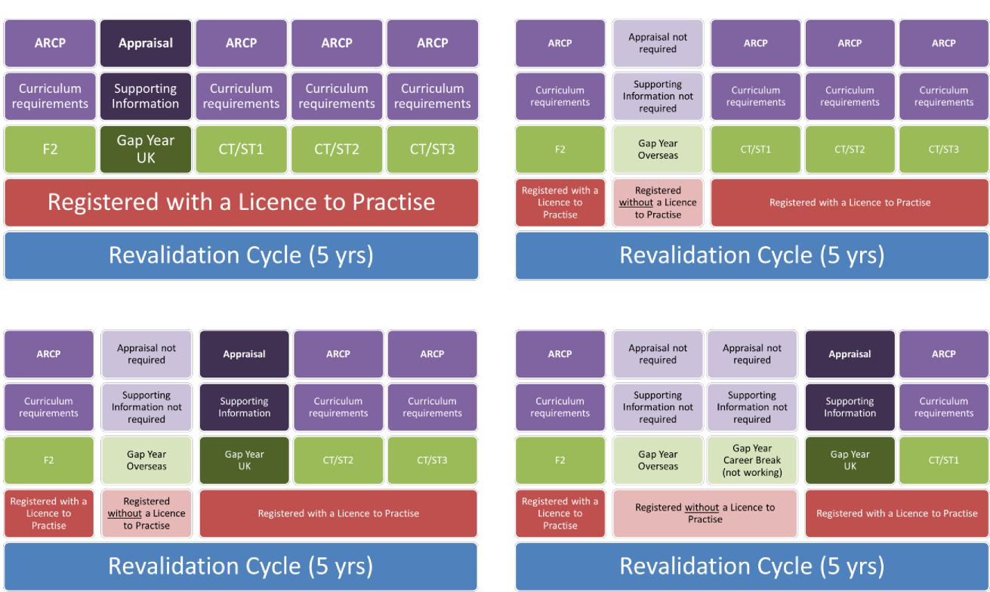
Depending on what they do during their gap year, they may have periods where they are not licensed, or where they are participating in annual appraisal instead of ARCP. The following examples depict a five-year revalidation cycle with different scenarios:
One Gap Year – Working in the UK One Gap Year – Working Overseas
Two-Year Gap – 1 Overseas, 1 UK Three-Year Gap – 1 Overseas, 1 Career Break, 1 UK

Doctors in Training Thames Valley?
When will I revalidate?
Every 5 years from point of full registration and at the point of CCT
as long as there is sufficient / up to date evidence and no ongoing or unaddressed fitness to practice concerns

What do I need to do?
Connect to the appropriate Designated Body via your GMC online account
Provide appraisal evidence from any non-training posts
Engage with training
Complete your Form R and other documentation required for ARCP
Check that you have been revalidated before you leave at CCT

What actually happens?
When your submission date is < 12 months away you are ‘under notice’ and appear on the list of doctors due for revalidation
The revalidation team access the relevant information from the systems but may contact you if anything further needed
A recommendation is made to the GMC
You will receive an email once the recommendation has been made
The GMC approve the recommendation and will confirm your new revalidation date

Questions?
england.revalidation.tv@nhs.net

Adapted from original document produced by Maisie Shrubsall, Revalidation Manager and Dr Geoffrey Wright, Associate Postgraduate Dean, Health Education England South West 2017

