HEE-TV Quality Committee

Terms of Reference

Version: | 4.0
Date of Authorisation: | June 2021
Name and Job Title of author: | Simon Smith Associate Dean for Quality  Gillian Baker Quality Lead Practice Learning
Key individuals and/or Committees consulted during drafting: | Quality Committee  Assurance Committee  Senior Leadership Team
Date issued: | May 2017
Review date: | Annual from date of issue

Document History:
Version | Date | Review date | Comments
1.0 | May 2017 | May 2017
2.0 | 9.8.17 | 11.8.17 | Amended following Assurance Committee meeting on 7.8.17
3.0 | February 2020
4.0 | June 2020 |  | Updated after organisational re-configurations  To be reviewed by QC

Remit & purpose

- The Quality Committee will be a multi-professional committee.

- The Quality Committee will have oversight of all clinical learning environments in HEE-TV, encompassing non-medical, medical, dental, general practice [primary and secondary] and pharmacy training programmes.

- The Quality Committee will be responsible for the quality management of the clinical learning environment.

- The Quality Committee will provide assurance that clinical learning environments meets the standards for education and training as set by Health Education England [HEE], and regulatory bodies including the GMC, NMC and GPhC and GDC

- Quality Committee activity will be informed by and follow the HEE Quality Strategy, Framework and Handbook

- The Quality Committee will have both operational and strategic areas of responsibility.

Governance

- The Quality Committee will be chaired by the HEE-TV Associate Dean, Quality, who will report to the Postgraduate Dean.

- The Quality Committee will be accountable to the HEE-TV (and SE) Senior Team and the South East Regional Directors through the South-East Regional Education Quality Management Oversight Group [see Appendix 1].

Main areas of responsibility

Strategic responsibilities:

- The Quality Committee will be responsible for reporting on the degree to which Placement Providers are ensuring requirements and standards of the HEE-Quality Strategy and Framework are met.

- The Quality Committee will have oversight of the HEE-TV Education Quality Risk Register which will be used to populate outgoing quality reports, including those to HEE National, Quality Surveillance Groups, regulatory bodies, and others as required [Appendix 2].

- The Quality Committee will have oversight of local and regional trends emerging in relation to the quality of education and training and will provide both insight and foresight in the management of concerns.

- The Quality Committee will identify and encourage dissemination of best practice locally and regionally.

- The Quality Committee will ensure effective liaison with the system via oversight groups and reporting processes.
- The Quality committee will ensure effective intra-organisational liaison, see Appendix 2.

Operational responsibilities:

- The Quality Committee will have oversight of all issues relating to the quality of education, and the process by which they are addressed, managed and resolved.

- The Quality Committee will monitor progress to address risks and resolve all issues and concerns arising.

- The Quality Committee will ensure that HEE quality processes are followed (eg Intensive Support Framework, report publishing SOP).

- The Quality Committee will scrutinise reports related to quality interventions undertaken and ensure requirements and recommendations in these reports are reviewed and monitored.

- The Quality Committee will determine the most appropriate quality intervention on the basis of available evidence and data, ensuring that any intervention is prepared for in a timely manner.

- The Quality Committee will, in partnership with the relevant education and/or placement provider, make requirements on the continued suitability of placements.

- The Quality Committee will receive, critically evaluate and validate where appropriate, reports from placement and education providers, including: placement provider self-assessments; placement provider Education Contract self-assessment reports; junior doctor contract exception reports, completed risk assessment reports and action plans; responses to national and local surveys; and other data sources.

Membership

- Head of Quality, Chair**
- Postgraduate Dean* [or nominated deputy]
- Business manager HEE-TV
- Quality Lead – Practice Learning*
- Quality Manager
- Quality Support Administrator
- Lay Representative
- Chair/Deputy Chair from the Trainee Advisory Committee**
- Non-medical Learner Representatives (eg Student Council representative) **
- One/Two co-opted, experienced clinical educators**
- Other co-opted members, representing providers, as appropriate [eg DME Representative, LEL Representative]
- Ad hoc invited professional and programme leads.

Quorum
The Quality Committee will be considered quorate providing that there are no fewer than five members in attendance, three of whom should be clinical representatives [registered with the appropriate regulatory body] one of whom should be in current practice and one of whom should be the Head of Quality, or the Postgraduate Dean. Clinical Representatives are identified above by an * asterisk. Current practice representatives are identified above by double asterisks **.

Frequency of meetings
The Quality Committee will meet monthly. The length of meeting will be determined by the agenda.

Appendix 1 Governance

Appendix 2 Reporting

Regional to National reporting

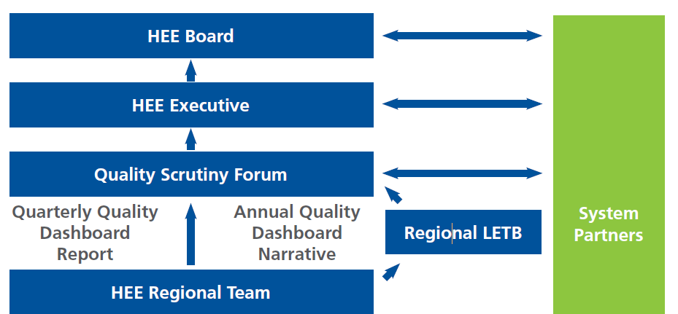

QC (TV) to Regional reporting

Reports to:

HEE:
EQMOG will report to the SE Risk and Safety Oversight Group
12+ risks shared with via QRR with national Quality team (JSOG/QSF)
Training Hubs and Primary care are represented on the above
Regulators:
GMC has the Quality Reporting System (QRS) for reporting 12+ risks relating to medical training
External partners:
Emerging Concerns pathway exists to report issues to external partners, i.e. NHSE/I, ICS etc, and regulators
ICS through Oversight and Scrutiny Committees (TV Dean attends)

Shares information with:

Sharing also occurs as a result of regional interdependencies as below:
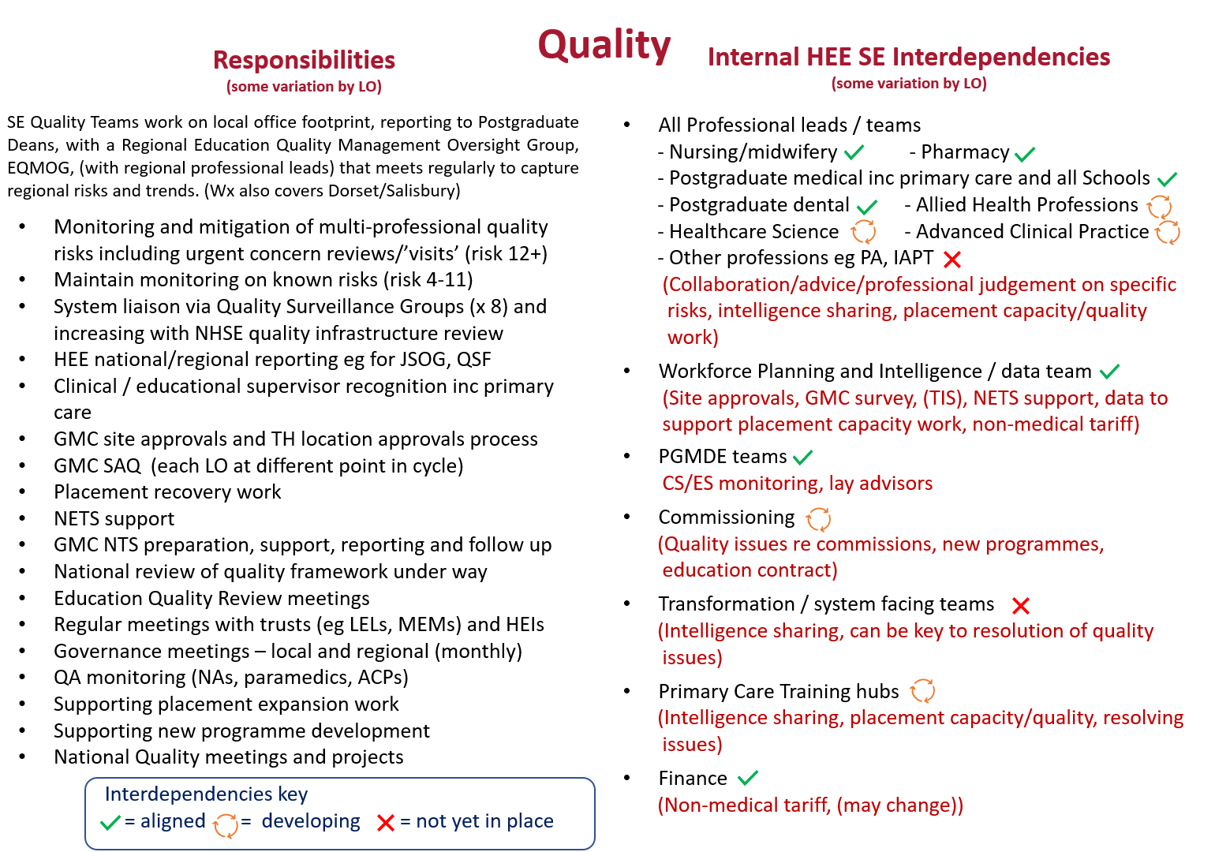

Additionally:
There is a locally agreed SOP/statement of principles for QC and Quality Team for the handling of feedback from learners.
Minutes are shared with attendees, and DMEs via Sharepoint site.
Associate Dean for Quality updates HoS/DME meeting, AD group, and TV-TM, and attends EQMOG, and regional Quality team meeting.
TV Quality team has annual meetings with Local Education Providers and Specialty Schools
Quality Lead for Practice Learning meets regularly with HEI and Providers

Appendix 3 Example agenda
Quality Committee
Date:
Time: 9.30 to 12.00
Venue:
Chair – Associate Dean for Quality

Agenda (Example)
No. | Item | Presented by | Papers
Attending:
1. | Apologies:
2. | Declaration of Conflicts / Competing Interests | All
3. | Minutes from previous Quality Committee meeting  - Accuracy b) Action Tracker | SS
4. | 9.45am Example Trust to present plan for ST3 year
5. | 10.00am Example Trust to present plan for ST3 year
6. | Non-medical update | GB
7. | National Education and Training Survey [NETS] update | QT
8. | HEE update:  Regional structure and process changes  Quality strategy/framework/handbook updates  Other policy updates/changes
9. | GMC NTS update
10. | GMC QA processes | LM
11. | Areas of good practice | All
12. | TAC update | LO
13. | DME update | DME
 | BREAK
14. | *** Programme - update | SS
15. | Review of Risk items:  Trust (verbal update)  Trust (written update)  QC review of ISF/ | All
16. | 12+ risk report (risks not covered elsewhere on agenda) | SS
17. | Any Other Business | All
Date of next meeting
Venue:

