Study Leave Guidance for
Dental Core and Specialty Trainees
undertaking training in the NHS England South East Region
(Thames Valley & Wessex)

NHS England is committed to supporting dental trainees in undertaking study leave activities to achieve their specialty curriculum and support professional development.

There is no cap imposed on any individual. Each study leave episode is considered on its own merit. However, it is important to bear in mind that the overall study leave budget is not limitless and has to be within budget.

General Terms
Dentists in postgraduate training are allowed up to 30 days of study leave per annum. Trainees working less than full time are entitled to study leave on a pro rata basis.

Application for external courses will not be approved if they fall on the Deanery mandatory study days.

Study leave can be used for:
- Courses/education activities to support dentists in training to achieve the curriculum requirements (scheduled teaching – Deanery study days and other Trust/Department study sessions are included within the 30 days)
- External/national courses, events, conferences, if a trainee is presenting (poster or oral presentation)
- Courses to help prepare for postgraduate exams
- Discretionary courses that add value and support the wider system

Study leave budgets do not cover:
- Royal College membership and e-portfolio fees
- Postgraduate exam fees
- Any statutory or mandatory training required to fulfil clinical role (this should be provided by NHS Trust)
- Interview expenses

Study Leave A-Z
Guidance regarding various aspects of study leave:

Accommodation expenses
Overnight accommodation expenses will only be reimbursed if you are travelling from a base destination (main place of work) more than 100 miles to the venue, or if the course runs longer than one day and the round trip exceeds 100 miles.

Accommodation costs to be covered by NHSE will be limited to the duration of the event plus one night, either before or after the event dates. Trainees must demonstrate value for money and book the lowest priced accommodation available (we recommend obtaining three quotes). Overnight costs will be reimbursed up to a maximum limit of £120.00 per night outside of London and £150 per night within London.

When staying with friends or relatives during a study leave activity, a flat rate sum (£25 per night) can be claimed, which includes an allowance for meals; receipts are not required.
Receipts must be provided for all accommodation expenses.
International Study Leave
Study leave for international activities (outside the UK require prospective approval from your Educational Supervisor, Training Programme Director and Associate Postgraduate Dental Dean. Any international study leave claims that have not been pre-approved by these roles will not be reimbursed.
International activities fall into two categories:
Curricular – Attending courses/events outside of the UK to meet curricular requirements. This will only be considered in exceptional circumstances and when the curricular requirements cannot be met by attending a similar opportunity in the UK.

Aspirational – Study leave that enhances the knowledge, skills and attitudes of the dentist in training, or enhances any aspect of patient care, but is not mapped to any direct curriculum requirements. For these special aspirational circumstances, it has been agreed that part-funding for one international conference or meeting may be approved on its own merit.
The part-funded of attendance, where approved – reflects both NHSE’s and your commitment to your development. Part-funding may be provided to support the conference/course fee or travel and accommodation costs (in line with local deanery guidance for claiming expenses), whichever is the lower amount.
The overnight accommodation rate for international study leave must not exceed £150 per night.
Subsistence expenses will not be reimbursed by NHSE for international study leave.
Receipts must be provided for all expenses otherwise your claim will not be processed.
Interviews
Study leave cannot be used to buy revision books, online resources, journal subscriptions, membership fees, accreditation fees, attend interviews or cover exam fees.
Leadership Management Courses
Dentists in training seeking leadership training should in the first instance be encouraged to access the free NHS Leadership Academy Edward Jenner. Trainees should only consider other options if these courses are not available.
Out of Programme
Dentists in training that are on an OOP for Research (OOPR), Career Break (OOPC) or Experience (OOPE) are not eligible to apply for study leave. Those on an OOP for Training (OOPT) will only be approved and funded where there is clear evidence linking the application to the specific curriculum requirement for the trainee’s individual specialty.

Parental Leave
Dentists in training on Parental Leave are eligible to apply for study leave.

Period of Grace
Dentists in their Period of Grace are not eligible for study leave funding. Once training has been completed any further professional development, skill, or knowledge acquisition during this period of time should be considered as continuous professional development (CPD).

Subsistence Expenses
Lunch allowance: £5 maximum. Receipts must include location and date of the event.
Evening meal allowance of £15 maximum can only be claimed if the event is taking place over two days.
Subsistence expenses will not usually be reimbursed by NHSE for international activities.

Receipts must be provided for all subsistence expenses otherwise your claim will not be processed.

Receipts and certificate of attendance for the study leave activity should be attached individually to the expenses claim.

Travel Expenses
All travel should be calculated from the base (main place of work) to the event and back.

You must use the most cost-effective transport means possible. NHSE reserves the right to only reimburse the cost of the cheapest fare.

By Car: Trainees will be paid at the rate of 30p per mile. The shortest practicable route should be taken. Only mileage in excess of the usual daily commute is eligible for reimbursement.

By Rail: Supersavers and standard class rail fares only. Tickets should be purchased in advance.
Copies of train tickets must be uploaded to Accent.

By Taxi: Expenses will be reimbursed for short journeys only such as from the nearest train
station to the venue where public transport is not practical, e.g. time of day. A receipt will be
required.

By Air: Only flight fee will be reimbursed (parking charges, excess baggage fee, subsistence will not be reimbursed).

Study Leave Categories

Essential activities are described as mandatory in curriculum documents by the relevant Royal College or Faculty and should assist Educational Supervisors to ensure that Dentists in training are meeting the requirements mandated by the curriculum.

Supporting activities are not mandated in the curriculum, but support the curriculum, with the Associate Postgraduate Dental Dean or Training Programme Director determining that attendance is of benefit to the Dentist in training. The study leave matrix should act as a guide for the trainee and Educational Supervisor to plan and schedule attendance at some of these events across the entire duration of training.

Discretionary/Aspirational activities enhance the knowledge, skills and attitudes of the dentists in training , or enhance any aspect of patient care, but are not mapped to any direct curriculum requirements.

Essential or Supporting activities will take priority over Discretionary/Aspirational activities, especially as national and local Study Leave budgets are finite.

Thames Valley & Wessex dental trainees apply for study leave via Accent
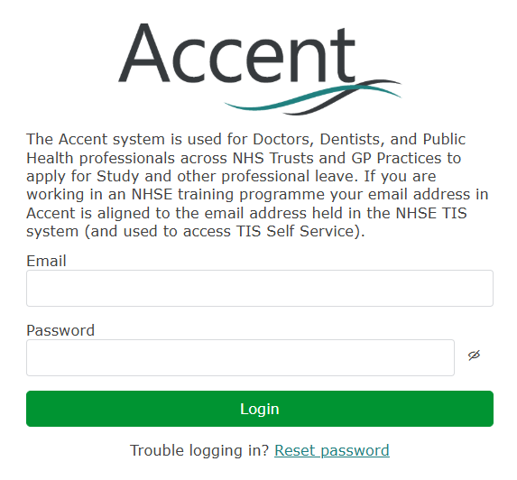

Study Leave Application and Estimated Expenses
Submitted study leave application and estimated expenses will be approved or
rejected by the NHSE Staff.

Actual Expenses
Following the approval of study leave application and estimated expenses, trainee needs to log in to Accent after the course has taken place and submit the actual expenses and receipts within 1 week of the course taking place.

Reimbursement via Salary (BACS)
Only Accent-approved study leave applications entitle trainees to claim reimbursement via Trust payment system.

